José Trigueiro 58119

**Use Case Diagram: Game Administration**

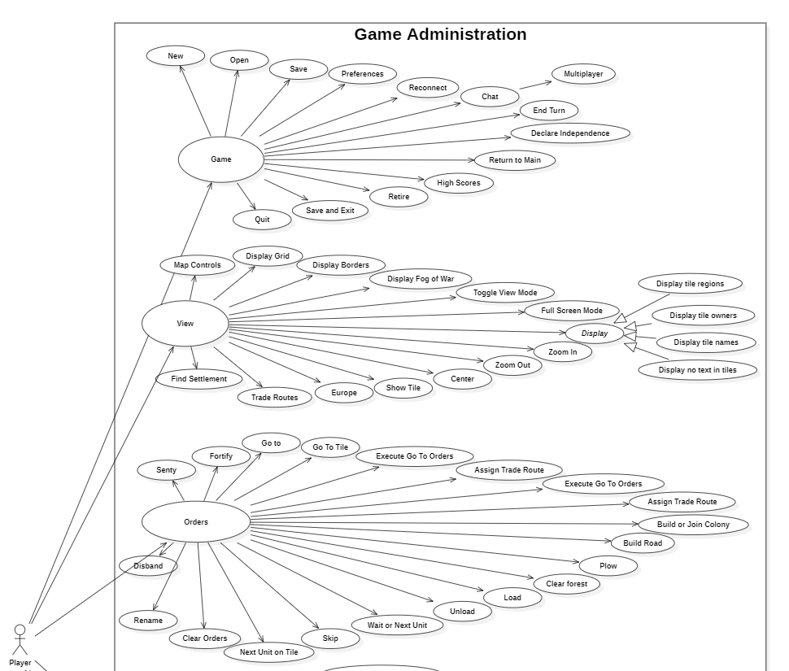

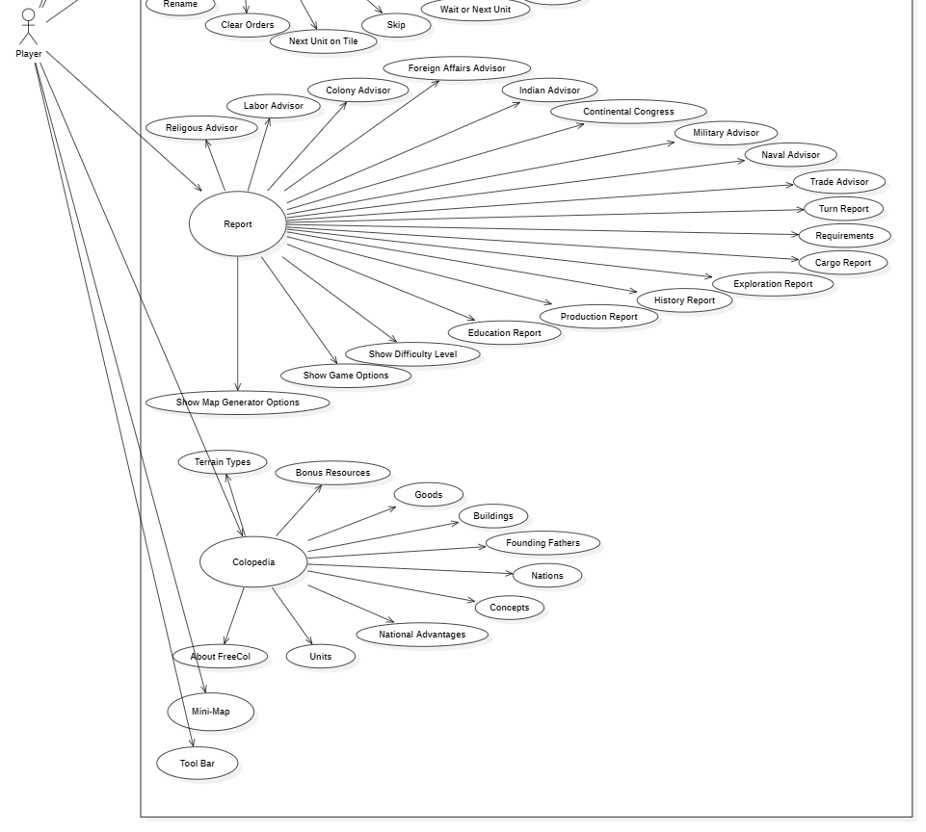

**Name:** Game Administration.

**Primary/Main Actor:** Player.

**Description:** The Player wants to select a **Game** option or **View** something in the game or hide it or have a **Report** of something done or finally check the **Colopedia** to learn about the game. Additionally can use the **Mini-Map** to view and **Tool-Bar** to manage the game.